{Search For Book}
Author (s): __Landon Leigh__ Date: ___9/3/2019___
Version: ___________
USE CASE NAME: | BOOK SEARCH | USE CASE TYPE
USE CASE ID: |  | Abstract: ☑
PRIORITY: | MEDIUM | Extension: □
INVOKED BY: | CUSTOMER
PARTICIPATING ACTORS: | CUSTOMER, LIBRARIAN
DESCRIPTION: | Customer uses system to search for book and then goes to section to get it.
PRE-CONDITION: | Customer needs to know which book they are looking for
TYPICAL COURSE  OF EVENTS: | Step 1: Search database for book
 | Step 2: Get book from location revealed from search
 | Step 3: Bring book for checkout
ALTERNATE COURSES: | Search does not find book, book is out of stock
POST-CONDITION: | Retrieve book for checkout if available and still want

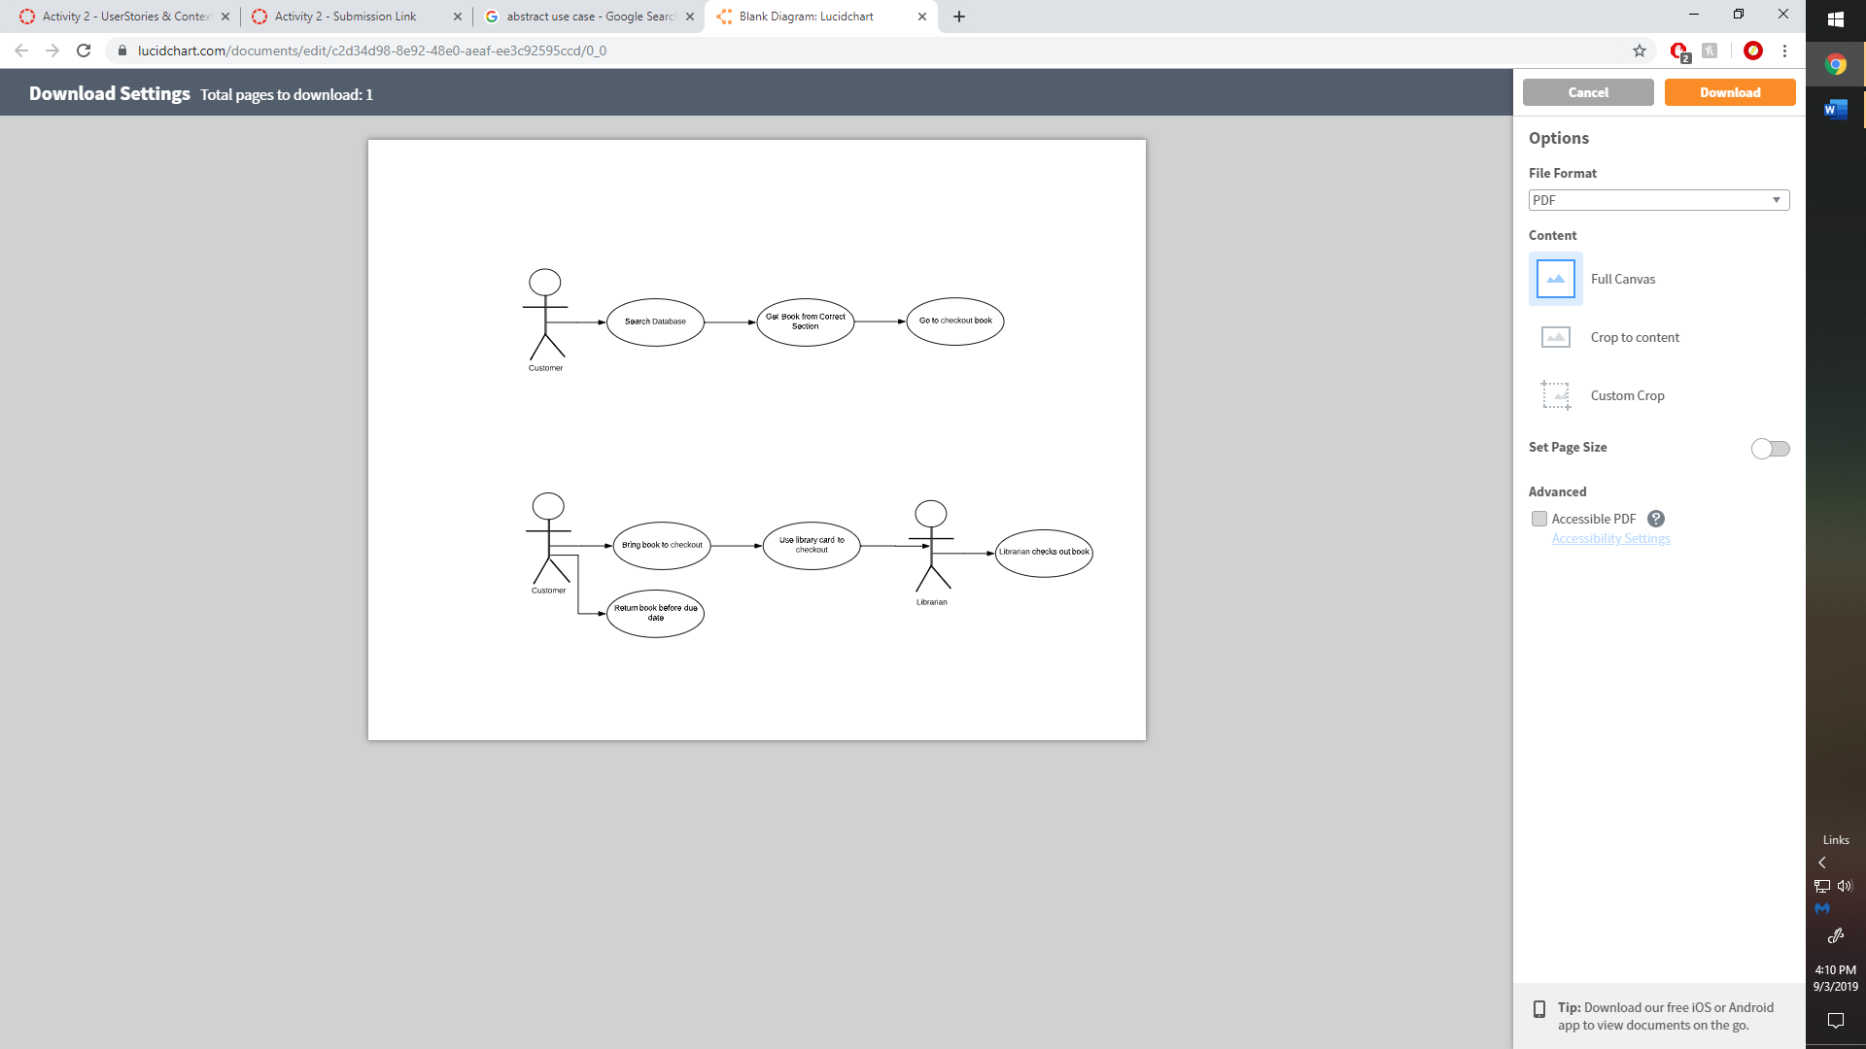

{Check Out Book}
Author (s): __Landon Leigh__ Date: ___9/3/2019___
Version: ___________
USE CASE NAME: | BOOK CHECKOUT | USE CASE TYPE
USE CASE ID: |  | Abstract: ☑
PRIORITY: | HIGH | Extension: □
INVOKED BY: | CUSTOMER
PARTICIPATING ACTORS: | CUSTOMER, LIBRARIAN
DESCRIPTION: | Customer checks out book with librarian.
PRE-CONDITION: | Customer has book to check out, customer has library card
TYPICAL COURSE  OF EVENTS: | Step 1: Bring book to checkout
 | Step 2: Present Library card to librarian
 | Step 3: Once finished, return book by due date
ALTERNATE COURSES: | Sign up for library card, get book from another location
POST-CONDITION: | Return book by due date

